**GDD FRONT COVER**

**ADD ARTWORk**

**TITLE**

## 

## Gameplay (ZCP)

# Single-Player Game

The gameplay is a single-player puzzle platforming. The reason for a single-player is that it is easier to create, and the team wanted to game to tailor the game experience on a character journey. The play side is in the mechanic and tutorial level pages.

The reason why the team wants a to emphasize the players journey within the gameplay is that it reflects upon the overarching narrative. The team is going to weave the narrative within the gameplay so that the player is more immerse and connected to the game as a hole. The reason why the team is doing any of this is that to build a fan base in the gaming community, which would help with profits and brand recognition.

# Main Themes of Gameplay

The main concept of this game is that the player will have to traverse platform puzzles to unlock abilities and those abilities unlocks level, so the teams game loop looks a bit like this…

Start

Unlock New Abilities

Unlock New Level

Solve Puzzle

The reason why the team decided to go for a simple game loop is that they are new to the technical system in this project. This means that the team will have a low scope of this project, however this means that the team can polish the game and their skills, which in turn will bring a better game overall.

# The Core Mechanic (ZCP)

## Overview

The core mechanic for this game is puzzle platforming. The reason for this is that these mechanics synergize with each other and the team creating this game have previous experience in puzzle platforming.

Puzzle platforming can be split into two different sections and each come with their own objective, so the team wants the platforming to feel like an adventure/exploration and puzzles to feel like difficult yet rewarding with their solution.

Adventure/Exploration is useful with helping the player understand that within games players must analyze and look from different perspectives to gain information in which would progress the game. This game goal is to combine both physical and mental perspective

# Other Mechanics (ZCP)

## Dynamic Gravity

In this Game one of the main mechanics is the use dynamic gravity for platforming and puzzle solving. The reason why the programing team is creating this is to immerse the player into the space level and give the game a USP. This dynamic gravity will allow the player to walk on walls, ceilings, and spherical objects so that they can traverse the level.

How the gravity is going to work is that each platform, which the programing team need the player to stick on will have all three dynamic gravity options as functions. Then the programing team will turn the necessary functions on when the player collides with a gravity field of that platform.

How these functions will work is by pulling the player to an area using an impulse and not a force. The reason for this is that a force in unreal happens instantly whereas an impulse happens gradually. Creating gravity this way allows the player to move on surfaces as they are not getting crushed by physics. The area which the player will be pulled to is depended on the active function.

## Push Mechanic

In this game the team wants the player to control and interact with the environment because the team wants to immerse the player within the game. How the team plan to integrate this is by allowing the player to push assets around, within the environment. The main use for this would be use for the platforming as the player can push platforms into position to make the terrain viable.

This push mechanic will work when the player is colliding with an invisible hitbox and presses the “E” key. Each hitbox will be connected to a piece or pieces of terrain, which will when triggered activate an in game tween to move that terrain.

# 

**Level One (ZCP)**

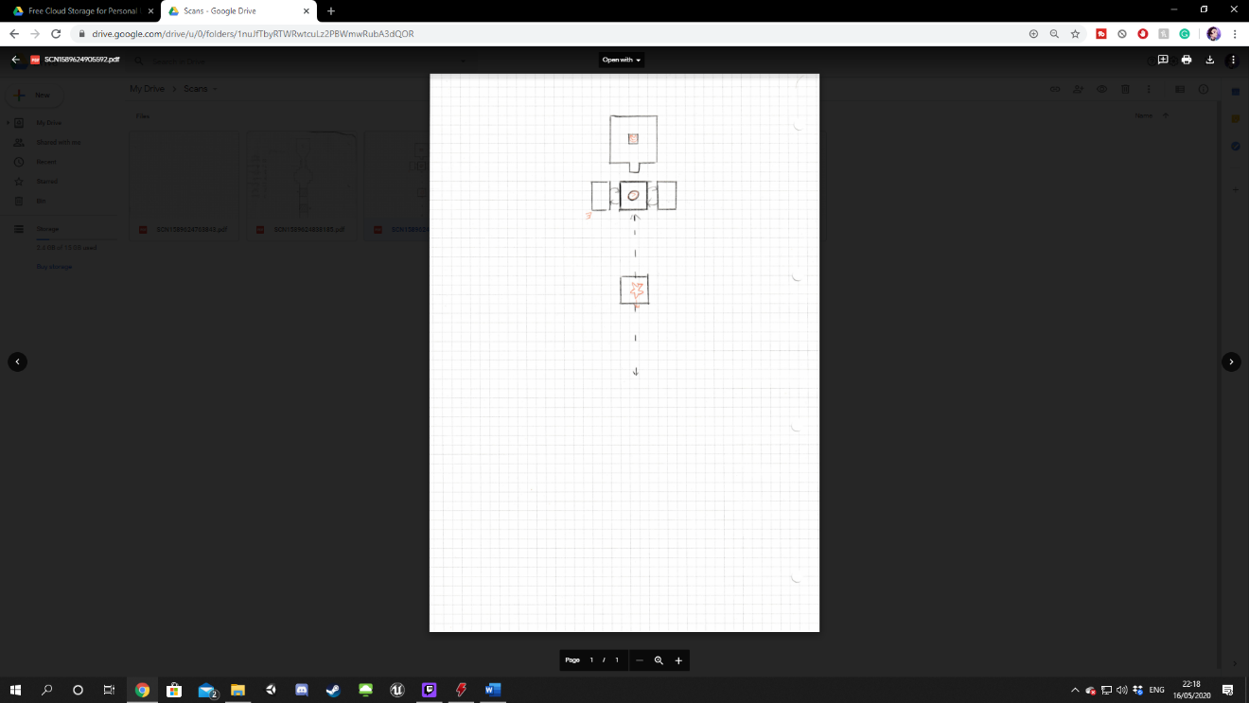**Layout Overview**

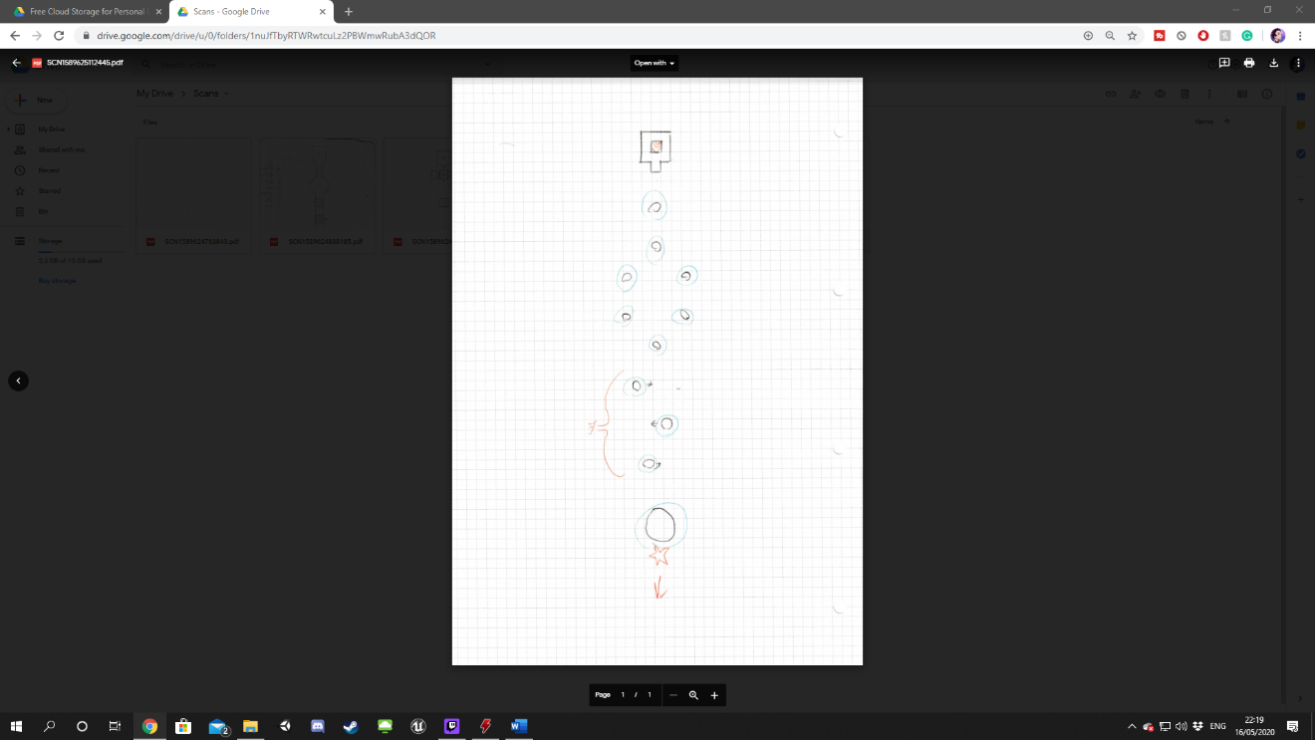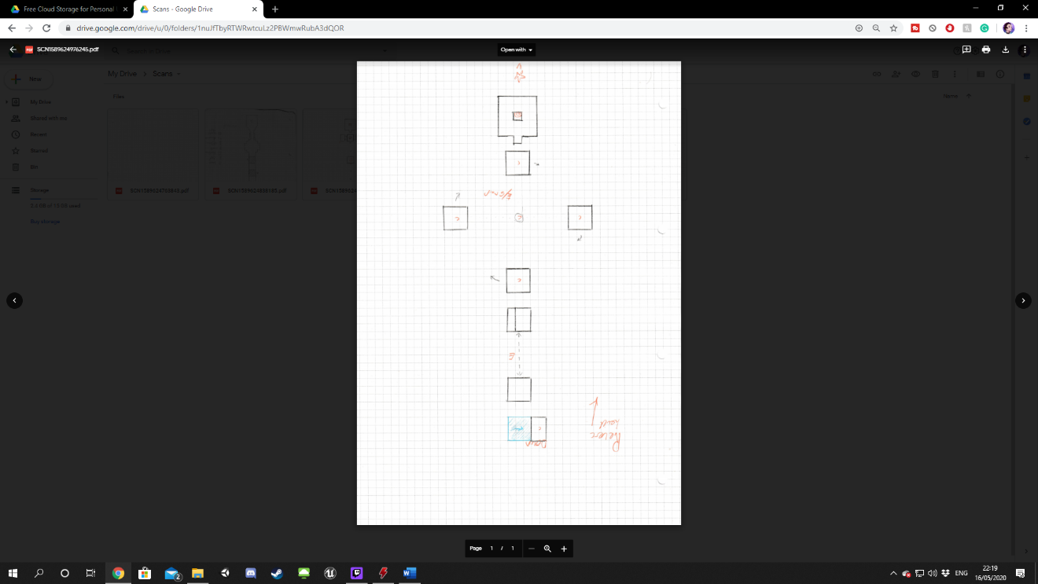

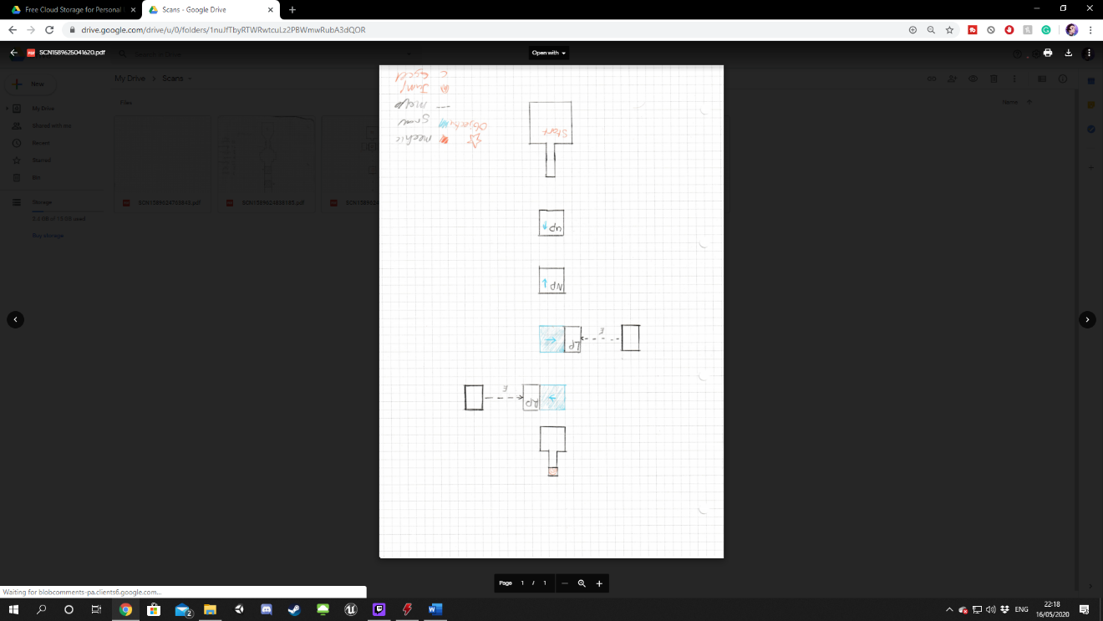

**Tutorial Level (ZCP)**

The first section of this level is designed to show the player how the in-game mechanics work. This is going to be done by simplifying the core mechanics and using semiotics to suggest what to do. How the team plan to implement this is by giving the player only one option at the start of the level, which is the platform in front of the player and show the player that items stick to that surface. The plan is that the player will repeat this twice to make them comfortable with this mechanic. All three sections are designed to build on the mechanics learned in the first section

**Technical Systems**

(ZCP)The system that the team will be using to create the game is Unreal Engine 4.24.3. The reason for this is that this is the most up to date Unreal Engine. The team chose Unreal to crate the game. The reason for this is that in Unreal it is easy to detect asset and move them. Why the team wanted these features is that it would make the creation of a prototype fast meaning that they could iterate the level more efficiently. The team plan to detect asset using simple hitboxes, which the player can trigger and sequencers to control the assets within the game. Another reason why the team chose to use Unreal is that it can use pre-made blueprints, which makes C++ coding a lot easier, so that the team can speed up production time.