Zachary Prole

24/08/2023

Research File

For Master’s Project

Contents

Video Game Word Definitions 1

Introduction 2

Sourcing Assets 2

World Design 3

Deep Rock Galactic – Deep Dive 3

Desired Path Theory 3

Ideas of Common Sense 4

Shared Experience Theory 4

Theory of Narrative Lenses 5

Object Oriented Level Design (OOLD) 6

OOLD Narrative Design 6

OOLD Mechanical Design 7

OOLD Summery 8

Puzzle Design 8

Puzzle Design Summary 8

Automation 9

Bibliography 9

# Video Game Word Definitions

Asset [1] - Shorthand for anything that goes into a video game – characters, objects, sound effects, maps, environments, etc.

Material [2] - Define the surface properties of the objects in your scene. In the broadest sense, you can think of a Material as the "paint" that is applied to a mesh to control its visual appearance.

# Introduction

In this document I will be analyzing and compiling information based on the concept of narrative level design. This information will then be used to help my decision when producing a small-scale level, which should be capable of telling a simple narrative.

The core section I plan to investigate are:

* Volumetric post-processors or VPP
* Concepts of Puzzle design
* Concepts of World Design

# Sourcing Assets

Within this project I plan to use Unreal Engine assets so I can focus on the level design itself. One of the problems with this is that I will need to use different asset [1] packs, which might not visually blend with the rest of the project.

A solution to this problem is a Volumetric post processor (VPP), what this does is overlay all assets within its radius to a set art style. It achieves this by recognizing what assets are within its radius and edits its material [2] or how lighting is applied.

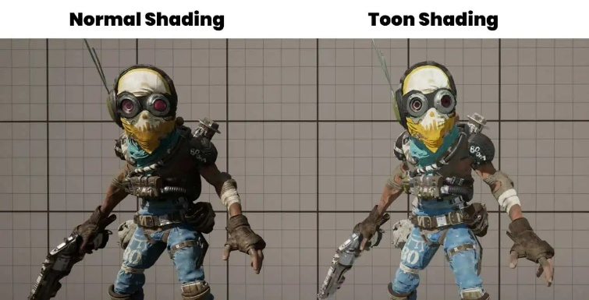An example of this is the “Cell Shaded” OR “Toon Style”. How this style works is by editing how light is generated within the world. Normally in-game light functions as if it was, were the shadows slowly becoming darker as a gradient, however within the game, designers can remove the gradient, which would show a gradual change in color, to something that has a more immediate effect.

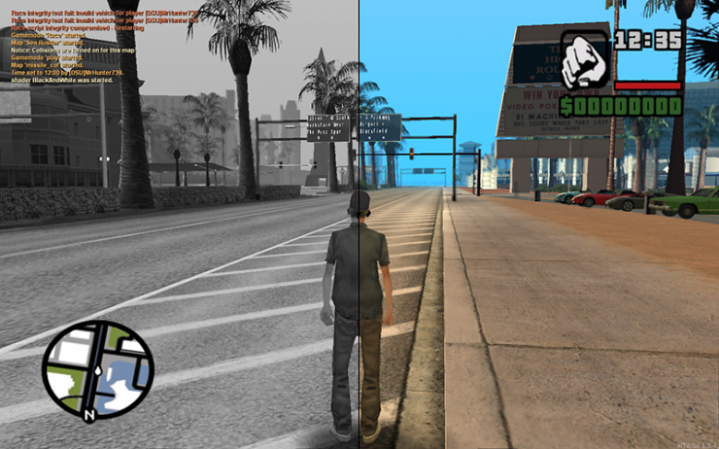Another technique a VPP can be used for is a “Black & White Contrast” shader. This is where the material [2], within the zone are changed to a grayscale of black and white dependent on the material [2] brightness.

Using a VPP I will be able to use multiple assets packs so that I will have the creative freedom to design my level.

# World Design

## Deep Rock Galactic – Deep Dive

### Desired Path Theory

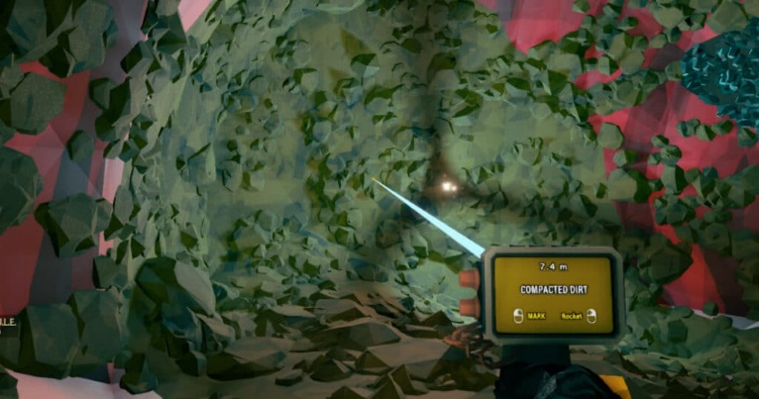Deep Rock Galactic is a game where players mine their own paths to objectives within a large map. One of the problems of this is that the players could get lost during their exploration. One way the developers guide the players without them realizing, is the use of different texturing within the cave systems. What I mean by this is that the designers use different textures and colors to persuade the players into the right direction.

The developers do this by coloring the walls, which they don’t want to be mined red and they make the textures/topology rigid. What this tells the players is that this is a “hard material”, which would take time to mine through. In conjunction with this the dev’s also place dirt walls with more organic textures/topology, which is a clear difference to its surrounding. These dirt walls tell the player that they are an easier path to take, which makes players gravitate to them.

This theory is called the desired path or also known as the desired line theory, dependent on profession. In Andrew Reinhard book “Archaeogaming” he states that “some players what more than that, more freedom to explore the game as they want to see it, not as the designers prescribed it. This could be classed as “counterplay,”” (Reinhard, 2018). This statement suggests that some players would like to take their own route through a game or their “desired path”, which in some cases could be detrimental to the user's experience. This means that the developers must have a “designed path”, just in case that the users “desired path” doesn’t reach the destination the dev’s intended.

### Ideas of Common Sense

Deep Rock Galactic also guides the player within their levels using their narrative. The main gameplay loop of this game sums up to find “x” about of item “y”. The game narrative helps the players find this item because of the game’s setting.

The items the players need to find are minerals, which can be found the deeper the player goes down. As this game is based on mining, the developers are using the players basic understanding of “miners dig down” to guide them. This is also helped by all caverns the players mines into always slope down, suggesting that going down is directly equivalent to progress.

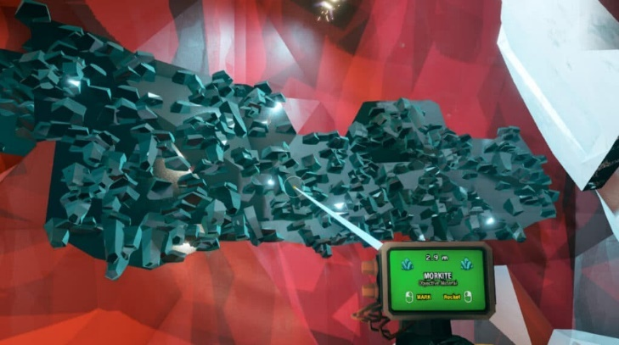This idea of tying this style of environment design to progress can mainly be seen in side-scrollers like “Mario”. The reason for this is that in “Mario” nothing happens until you move right on the screen, which suggests that moving right means progress, whereas within Deep Rock Galactic it uses the “Y” axis instead of the “X” to display progress.

### Shared Experience Theory

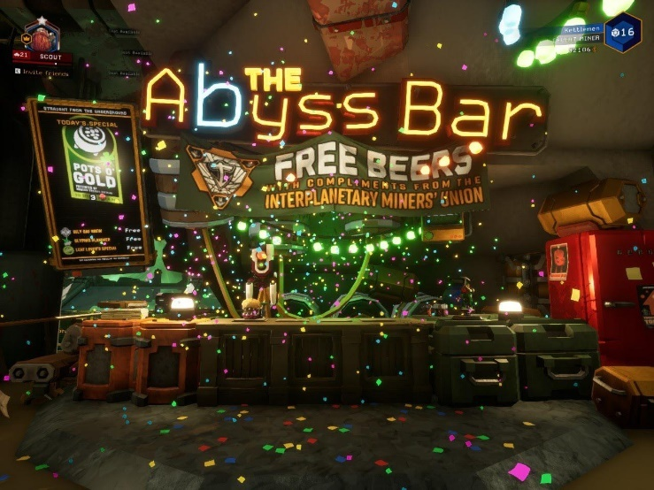Deep Rock Galactic is a team based multiplayer game. What this means is that the only way to complete the game is for the players to work together. This can be a problem as some players would have never met each other beforehand and in some cases the players would refrain from talking to each other. To solve this problem the developers, make the HUB or waiting room for the game interactive with the players. While waiting the players could grab a drink, dance together and play mini games to name a couple.

What this draws on is the shared experience theory and what this means is that people will bond together if they have experienced the same events. One research article published by Yale University states “that sharing an experience with another person, without communicating, amplifies one’s experience. Both pleasant and unpleasant experiences were more intense when shared.” (Boothby et al., 2014).

This theory was used within the level design to make pleasant experiences within the HUB for the players to bond over and make it more likely that they will support each other during the game, even if they don’t want to talk.

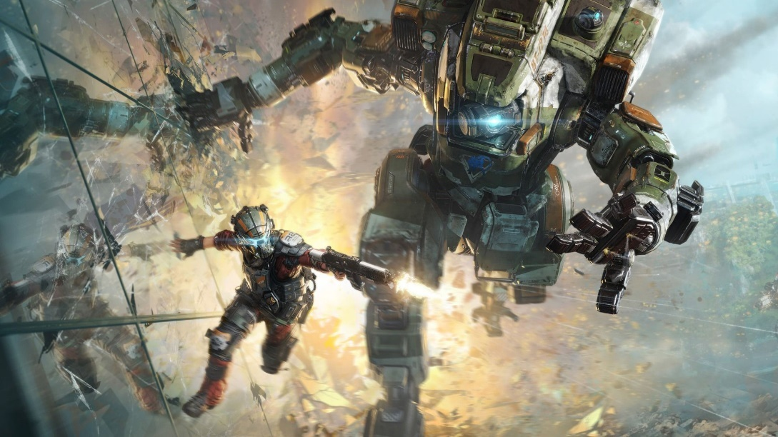I believe that this theory could also be replicated within a single player game. This would be done with the player and an NPC or non-playable character. One example I know of is the emotional bond within “Titanfall 2” of the player and his Mecha (Robotic suit of armor). This is done by the player grieving with Mecha when someone dies to celebrating together when they complete a puzzle, which would have been impossible without the other.

To sum up, developers can use shared experience theory to make a player bond with another player or NPC through the puzzles and narrative that they design in their games.

### Theory of Narrative Lenses

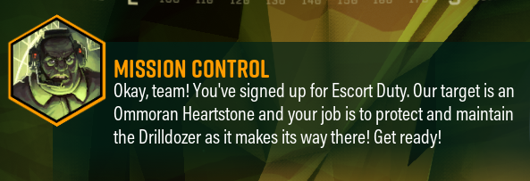Deep Rock Galactic uses a liner design when making quests for the player. What I mean by this is that the player is directly told what to do once they have completed their current task. The positive aspect of this style is that it is quite easy to understand the instructions given.

One of the reasons why the developers might have taken this approach is that the game can be overwhelming at times. What I mean by this is that the player must manage their resources while sculping a mine suitable for their task. This would take a lot of the players attention, so having a simpler quest system makes sense mechanically for this game.

The developers are also able to tie their quest system to the narrative. They do this with a pop-up of writing which is coming from “Mission Control”. This automatically tells the player that this is a trusted piece of information and suits with the theme of playing miner from a big organization.

This proves that having a simple quest design can be effective if it suits the world, it is built in.

Looking into this with lens methodology by Jesse Schell(SCHELL, 2008), this quest mechanic uses the lens of story(PG 279-280). What I mean by this is that the quest mechanic uses the game’s story to feel more natural and immersive. When looking into this the developers didn't need to have a story tied to the quest to make it functional, however “The story supports the other parts of the tetrad (aesthetics, technology, gameplay)” (SCHELL, 2008).

Deep Rock Galactic uses a liner design when making quests for the player. What I mean by this is that the player is directly told what to do once they have completed their current task. The positive aspect of this style is that it is quite easy to understand the instructions given.

One of the reasons why the developers might have taken this approach is that the game can be overwhelming at times. What I mean by this is that the player must manage their resources while sculping a mine suitable for their task. This would take a lot of the players attention, so having a simpler quest system makes sense mechanically for this game.

The developers are also able to tie their quest system to the narrative. They do this with a pop-up of writing which is coming from “Mission Control”. This automatically tells the player that this is a trusted piece of information and suits with the theme of playing miner from a big organization.

This proves that having a simple quest design can be effective if it suits the world, it is built in.

Looking into this with lens methodology by Jesse Schell (SCHELL, 2008), this quest mechanic uses the lens of story (PG 279-280). What I mean by this is that the quest mechanic uses the game’s story to feel more natural and immersive. When looking into this the developers didn't need to have a story tied to the quest to make it functional, however “The story supports the other parts of the tetrad (aesthetics, technology, gameplay)” (SCHELL, 2008).

## Object Oriented Level Design (OOLD)

Object-Oriented Level Design (OOLD), which was founded by (Kremers, 2022). Is a theory with multiple subbranches, but the core concept is that the player should be guided through the game using assets placed within it. The “branches” for this theory are the mechanical side and the narrative side. This whole project is basically based on this one theory of using objects to explain rather than audible explanation.

### OOLD Narrative Design

How the narrative side of this theory works is by having something within the game stand out, which could be done by size, color, sound, etc., which would then intrigue the player, leaving a lasting impression. The reason why the developers want to leave a lasting impression is that object then 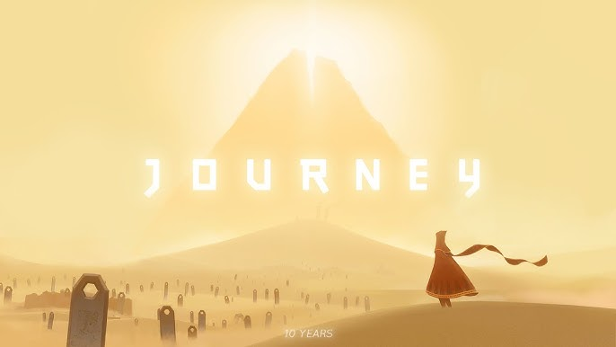becomes more significant to the player, and they could try and reach it. A great example of this is the mountains within “Journey”. The reason why this is “in my option” the best use of narrative based OOLD, is that in this game the player can’t speak and is never spoken to, yet when you start this game, you have a urge to go to this mountain. The reason for this is that this mountain is so visually captivating compared to its 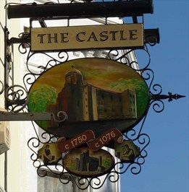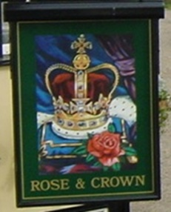environment, as it draws the player visually to it. This “urge” within the game only increases when the player discovers tablets depicting events on this mountain, reenforcing the primary object, while still using the same technique.

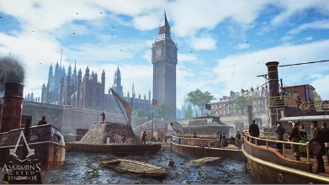Instead of using this theory to point out an objective for the player you can also use it to produce landmarks within the level. What I mean by this is that the player can guild themselves through the world map by gauging their relative location to an in-game landmark. The reason why this works is that all the techniques used to point out objective for the player also work in the production of landmarks. This theory has been used in real life centuries for the use of English pub names and logos. The reason for this is that most customers were illiterate, so pub owners designed the name and logo of their pubs to be visually understandable, so that people would understand where to go.

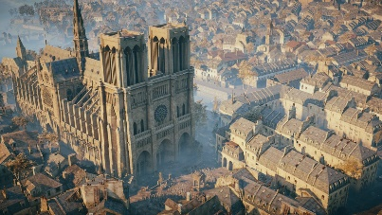A good video game version of this is the towers within “Assassin Creed”. The reason why these are extremely good as landmarks or natural waypoints is that they can be seen from most areas of the map. This allows the player to reorientate themselves by looking for one of these landmarks, if they find themselves lost on the map.

### OOLD Mechanical Design

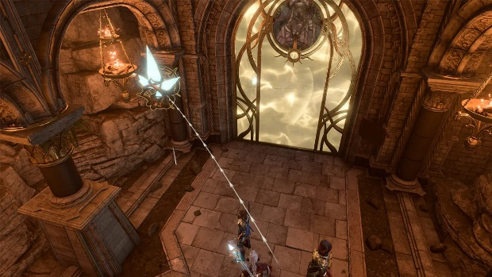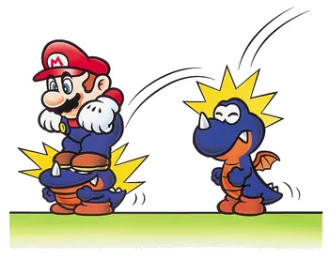“The concept, as the name already implies, is derived from the practice of object-oriented programming. It is an incremental technique where assets are introduced and then reused with variations.” (Kayali and Ortner, 2019). This statement suggest that the developers can impermeant mechanical learning using in-game assets, if there is slight variation. Another term for this theory is called “the rule of three” (Doucet, 2010). This technique is quite common in Nintendo games, like “Super Mario Bro’s” and how it works is by teaching the player a mechanic, then putting a twist to it and finally challenging the player’s skill of that mechanic. In the case of “Super Mario Bro’s”, the mechanic is jumping and at first the player must use their mobility to traverse the “objects” or assets within the environment, then the player must use this ability to defeat an enemy. Then at the end the player must do both at the same time.

Another good example of this can be found in “Baldur’s gate 3”, this is where the player must walk along a corridor to get to the next area, however, their path is blocked until they break the crystals. There are three crystals and each having a particular way of getting to them, as they are hidden, so that they can be broken. This makes the player explore the environment around them, while also grounding the puzzle into the game.

### OOLD Summery

To sum up Object Oriented Level Design is a good theory to follow when designing landmasses and puzzles as it grounds the player into the virtual world, they’re currently in. It also helps the player visualize their development within the game as they are always progressing their knowledge of the environment or their mechanical capabilities.

# Puzzle Design

## Puzzle Design Summary

When I started this project, I wanted to make physics based lateral puzzles, this simply means puzzles that develop themselves. One theory for this is “the rule of three”, as the puzzle progresses as the game goes on. The reason why I wanted to design progressive puzzles is that is saves time on asset production and it gives a design challenge to try and reuse your puzzle in more on an initiative way.

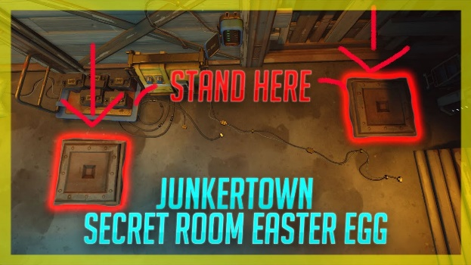When it comes to the physics side of the puzzle development, what I mean by this is that I want to use forces that can be found in real life physics, such as weight, gravity, momentum. Etc. The reason for this is that within the engine I plan to design my project in, it can handle physics properties quite comfortably.

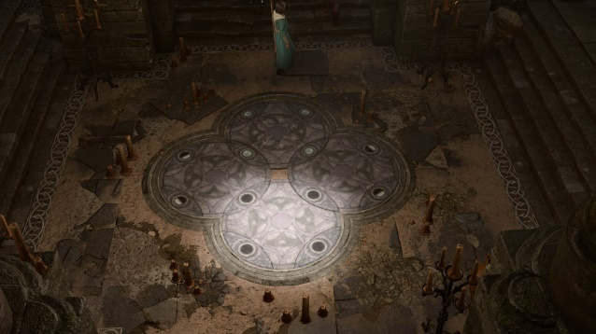One puzzle idea I have investigated is “pressure plates” and the basic concept is that they are buttons, which the player can walk over to activate an object, like a door. These buttons work when there is enough mass atop them, and then the press down activating the desired outcome. A good example of this is one of the spawn rooms in “Overwatch”. In this zone two players must stand on each of these buttons to unlock a hidden room within the spawn zone, that provides information on the map the players are about to play on. The reason why this is good is that it combines gameplay mechanics with the shared experience theory.

Another Physics puzzle that that I have investigated is the “shifting tile” puzzles, more particularly the moon puzzle in “Baldur’s Gate 3”. In this puzzle the player must move the tiles to correspond with how the map is lit. The reason why I found this puzzle interesting is that it uses rotational momentum to develop the puzzle, while being played. What I mean by this is that 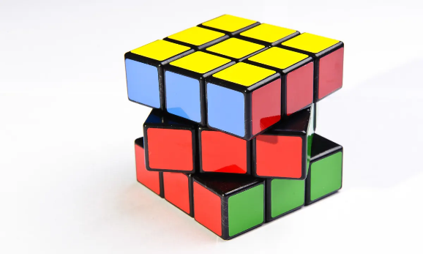if the player makes a wrong turn, they could be making it harder to solve. A real-life example of a puzzle like this would be a “Rubik’s Cube”, as each turn develops the game.

# Automation

Automation within the game development space is becoming more mainstream, thanks to the new tools & engines streamlining the process it takes to make automation happen. A good use for automation is a foliage generator within the world landscape. The reason for this is that it is cable of taking out most of the monotonous work of producing a polished looking landscape. How foliage generators work is by using an having a “parent” tree, which the game spawns anywhere within a designated zone, of the designers choice. Then when it is placed the parent will then spawn “child” version of itself. These “children” can be different models and all models can have their sizes randomly adjusted to make the forest or foliage patch more realistic. Then this is looped until they can’t find any more space to spawn in the foliage within the zone.

# Bibliography

* Reinhard, A. (2018) *Archaeogaming: An introduction to archaeology in and of video games*. New York: Berghahn Books.
* Boothby, E.J., Clark, M.S. and Bargh, J.A. (2014) *Shared Experiences Are Amplified*, *Psychological Science*.
* SCHELL, J. (2008) *The Art of Game Design: A book of lenses*. Boca Raton ; London ; New York: CRC Press/Balkema.
* Kremers, R., 2022. [online] Linkin. Available at: <<https://uk.linkedin.com/in/rudolfk>> [Accessed 24 August 2023].
* Kayali, F. and Ortner, J., 2019. Level Design Practices for Independent Games. In: C. Totten, ed., Level Design Processes and Experieces, 1st ed. Florida: CRC Press, p.134.
* Doucet, L. (2010) Practical game design : The rule of threes, Game Developer. Available at: https://www.gamedeveloper.com/design/practical-game-design-the-rule-of-threes (Accessed: 24 August 2023).